**DATABASE PROJECT – GROUP 2**

Topic: Database management system for clothes store – Entique Garden

1. **Problem description**

It is a fact that the number of small businesses selling clothes is heavily expanding with every passing day, and so does the need to have an efficient and effective management system of those products. Such a system provides a user-friendly way for staff to control what is available inside the store, know who a regular customer is and also allow business owners to control the amount of money coming in and out, and to examine staffs’ performance. Thus, our team choose this problem with the hope to provide a simple, yet robust solution so that everyone can become business owners. Please note that this database design should only be effective with small business whose number of warehouse is one. For larger corporations, the proposed design might be not

* **Users**
  + Managers: The manager can update, insert, and delete products of the store. The manager can also track the performance of the staff by assessing the selling history of the staff that he/she manages. Finally, the manager also handle the imports of goods into the store.
  + Staff: These people are day-to-day workers that serve the customers. Staff can view the products that are available instore and create orders containing those products. The staff can create new customer record and adjust the information of the existing ones if anything changes. (Finally, the staff also handle the returns of products should the customers are dissatisfied)
* **The proposed automated functionality and triggers:**
  + Auto update the number of available products of each type after a purchase been made.
  + Auto update the number of available products of a certain type after an import been made
  + Auto update the credit and the rank of customers after a purchased been made.
* **Constraints:** 
  + Customers can only purchase products whose quantity is greater than 1
  + Each type of product will belong to at least one category, and staff can find all products that belong to a particular category.
  + The system manages according to each type of product (differentiated by the combination of Model, color and size)
  + Whenever a new product is created, the ID of the product will be checked according to the format: MODEL-COLOR-SIZE. E.g.: 12345-RE-M: Model: 12345, Color: Red, Size: M
  + Status of product?
  + Each type of product will be subjected to none, one, or many discount. Howevver, when checkout, the customers can only apply for 1 discount, which will be set to what most benefits the customer. The discounted price will be calculated automatically.
  + Customer can sign up with the staff to be close customers (holding a customer record). After each purchase, the customer will receive a certain amount of credit amounting to 10% of the final bill. There are four levels of customers: Copper (credit < 100), Silver (100 <= credit <=999), Gold (1000 <= credit <=4999), and Diamond (credit >=5000). There will be different discounts for different rankings.
* **Utilities:** 
  + Staff and Manager can check the purchase history of all customers in a certain time period. (E.g.: Query all orders placed between the 1st and the 31st of January, 2023).
  + Staff and Manager can check the purchase history of a single customer. (E.g.: Query all purchase of Mr. B - the key is the phone number)
  + Manager can see the changes in price of a single product
  + Manager can see the flow of money (in and out) from a certain period.

1. **Entity**

Figure 1. Table Schema and Mapping

1. **Customers (Manage customers’ information)**

|  |  |  |
| --- | --- | --- |
| **No** | **Attributes** | **Explanations** |
| 1 | **Phone** | User’s personal phone number – the primary key |
| 2 | first_name |  |
| 3 | Last_name |  |
| 4 | Dob | Date of Birth |
| 5 | Gender | The gender will be checked in (‘male’, ‘female’, ‘others’)?????? |
| 6 | Email |  |
| 7 | address |  |
| 8 | Member_type | will be in (‘Silver’, ‘Gold’, ‘Diamond’)???? |
| 9 | address |  |

1. **Products (Manage products’ information)**

|  |  |  |
| --- | --- | --- |
| **No** | **Attributes** | **Explanations** |
| 1 | **Product_id** | Unique, primary key |
| 2 | name |  |
| 3 | size | Will be checked????? IN (‘M’, ‘L’, ‘XL’) |
| 4 | color |  |
| 5 | description |  |
| 6 | Category_id |  |
| 7 | Sale_price |  |
| 8 | Quan_in_stock | Will be checked? (>=0) |
| 9 | Discount_id |  |

1. **Orders (Manage different orders)**

|  |  |  |
| --- | --- | --- |
| **No** | **Attributes** | **Explanations** |
| 1 | **Order_id** |  |
| 2 | Order_date |  |
| 3 | Customer_id |  |
| 4 | Staff_id |  |
| 5 | discount |  |
| 6 | Total_amount |  |
| 7 | point |  |
| 8 | Payment_type | will be in (‘Cash, ‘Card’)????? |

1. **Orderline (Connect the orders and products)**

|  |  |  |
| --- | --- | --- |
| **No** | **Attributes** | **Explanations** |
| 1 | **Order_id** |  |
| 2 | **Product_id** |  |
| 3 | quantity |  |
| 4 | Total_amount | Có nên thêm.1 cột discounted price????? |
| 5 | Discount | Referenced the discount_id |

1. **Staffs (Manage staff’s information)**

|  |  |  |
| --- | --- | --- |
| **No** | **Attributes** | **Explanations** |
| 1 | **username** | Primary key |
| 2 | password |  |
| 3 | Manager_id |  |
| 4 | Permissions | Will be checked? (‘Admin’, ‘Regular’)????? |
| 5 | First_name |  |
| 6 | Last_name |  |
| 7 | DoB | Date of Birth |
| 8 | Gender | The gender will be checked in (‘male’, ‘female’, ‘others’) |
| 9 | phone |  |
| 10 | email |  |
| 11 | address |  |
| 12 | Hire_date |  |
| 13 | Off_date | Default value = “null”???? |
| 14 | Working_status | Có nên xoá không?????? |

1. **Product_history (Track the import of goods into the store)**

|  |  |  |
| --- | --- | --- |
| **No** | **Attributes** | **Explaination** |
| 1 | **Date_in** | Primary key |
| 2 | **Product_id** | Primary key |
| 3 | Quantity |  |
| 4 | Entry_price |  |
| 5 | Manager_id |  |

1. **Discount (Manage discounts)**

|  |  |  |
| --- | --- | --- |
| **No** | **Attributes** | **Explaination** |
| 1 | discount_id |  |
| 2 | name |  |
| 3 | description |  |
| 4 | Discount_percent |  |
| 5 | Begin_date |  |
| 6 | End_date |  |

1. **Price_history.(Track the changes of price of products)**

|  |  |  |
| --- | --- | --- |
| **No** | **Attributes** | **Explaination** |
| 1 | Product_id |  |
| 2 | Date_change | Nên có checked ??? (Date >= today???) |
| 3 | New_price |  |

1. **Categories (manage different categories of products)**

|  |  |  |
| --- | --- | --- |
| **No** | **Attributes** | **Explaination** |
| 1 | Category_id |  |
| 2 | name |  |
| 3 | description |  |

1. **Entity-Relationship Diagram**

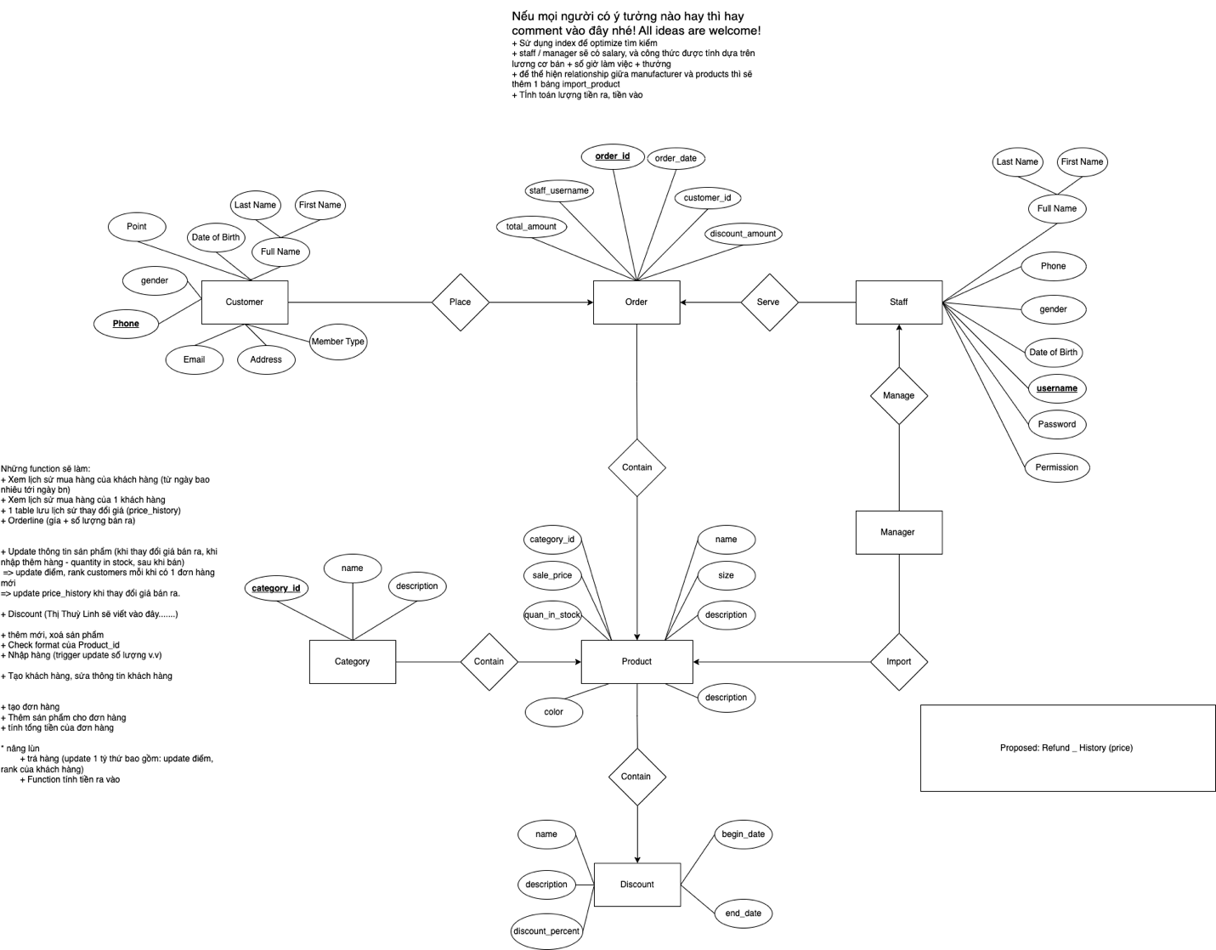

Figure 2 - Entity relationship Diagram

1. **Team members and Work allocation**
2. Team Members

|  |  |  |  |
| --- | --- | --- | --- |
| **STT** | **Name** | **Student ID** | **Role** |
| 1 | Nguyễn Thị Linh | 20200349 | Lead |
| 2 | Nguyễn Tấn Tiến | 20205172 | Member |
| 3 | Vũ Minh Dũng | 20205197 | Member |

1. Responsibility

A

|  |  |  |
| --- | --- | --- |
| **STT** | **Work** | **Members** |
| 1 | Insert Data | Linh, Tiến, Dũng |
| 2 | Write report | Tiến |
| 3 | Slide | Linh, Tiến, Dũng |
| 4 | Trigger and Function | Linh, Dũng |
| 5 | Overall Design | Linh, Tiến, Dũng |
| 6 | Entity Relationship Diagram | Linh, Tiến, Dũng |
| 7 | Schema and Mapping | Linh, Tiến |
| 8 | Write Query | Linh, Tiến, Dũng |

*This summary is the first draft of our team about the total database design and implementation. There will definitely be some mistakes or unsuitable features that need adjusting. Thus, we would really appreciate any of your comments to help us perfect our work! Thank you!*